ED-TECH INSTITUTE OF TECHNOLOGY

DEPARTMENT OF DATA SCIENCE AND ANALYSIS

CANDIDATE: THUTO MASOLE

BUSINESS INTELLIGENCE CONSULTANCY TO ALPHA DREAMERS BANK

**Probem statement**

Alpha dreamers Banking consortium is a financial institution that provides business loans, savings accounts, and checking accounts for individuals and businesses.

A new wing of business intelligence has been initiated to assist the loans department to automate, predict and formalize the business processes since the loans department has realized that there is a high defaulter rate for personal loans and, measures must be put in place to minimize the defaulter rates.

**BUSINESS INTELIGENCE EXPLORATORY ANALYSIS**

In assessing personal bank loan defaults, we pay attention to select parameters. Precisely, Marital status, house ownership, age groups and work experience.

The analysis shows that single, rented accommodation, 0-20 years of work experience and aged people of 60+ years with inadequate work experience tend to default loans the most.

IN TERMS OF ASSESING BANK DEFAULTS ACCORDING TO THE VARIOUS AGES OF THE BANK`S CLIENTS, IT IS EVIDENT THAT INDIVIDUALS OF AGE 60 AND ABOVE TEND TO DEFAULT PERSONAL LOANS THE MOST. THIS COULD BE BECAUSE, MAJORIRY OF INDIVIDIUALS IN THIS AGE GROUP ARE RECENTLY RETIRED AND LONG RETIRED PEOPLE WHO MAY HAVE NOT SUBSTANTIALLY AMMASED FINANCIAL ASSETS TO PROVIDE THEM WITH THE NECESSARY LEVERAGE TO MAKE CERTAIN FINANCIAL DESICIONS

Clients with 0-20 years of work experience are more likely to default on personal bank loans compared to those with 20+ years of experience due to factors such as financial instability, lower income levels, and higher living expenses early in their careers. Experienced workers typically have higher income, established credit history, and better financial management skills, leading to greater loan repayment capabilities

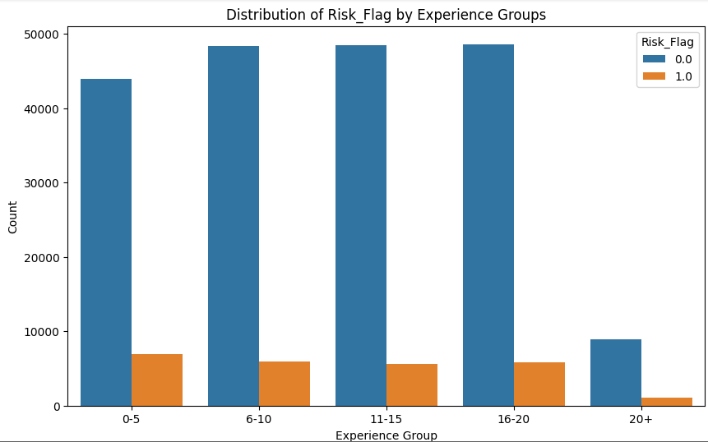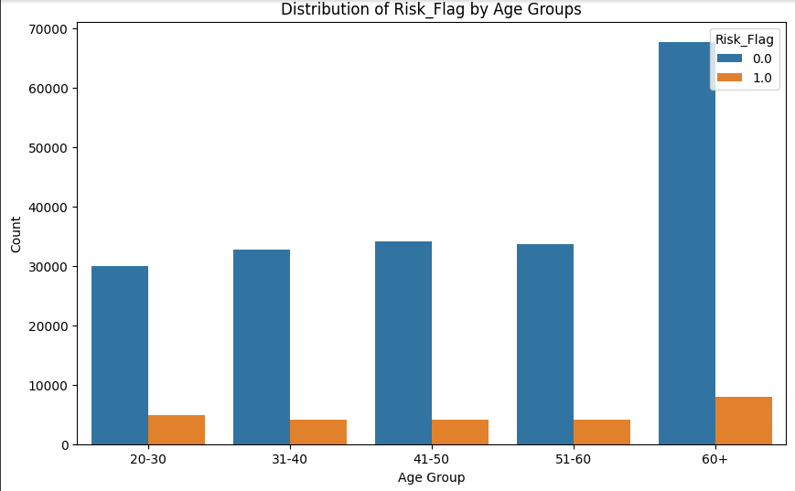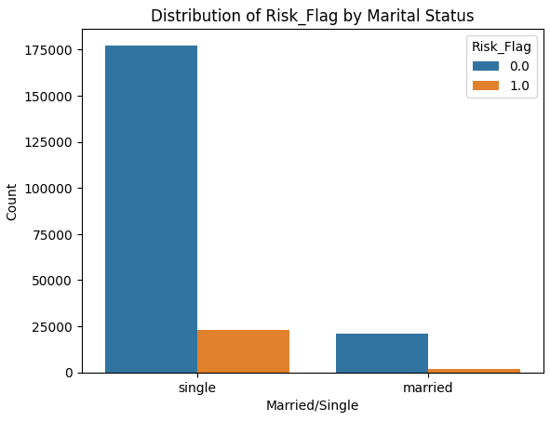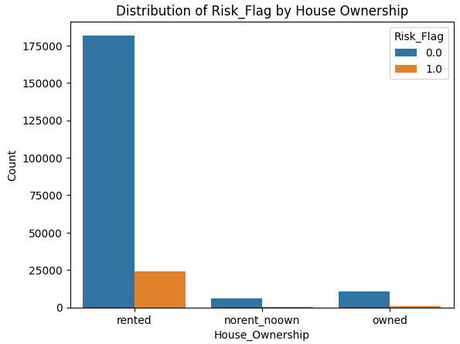

The distribution of Risk Flag by Marital status is such that a single individual is most likely to default payment of a personal loan. This implies that Alpha dreamers Bank should be warry of clients who are not yet married or do not show potential of engaging in a companionship. It can be explained that a single individual is most likely to make biased fanancial decisions

**A business intelligent solution**

After a thorough analysis of demographic and work experience data within Alpha Dreamers Consortium, I recommend the adoption of a credit score system to enhance decision-making processes. The findings have highlighted distinctive financial patterns among individuals aged 60+, those living in rented accommodations, and those with 0-15 years of work experience. By integrating credit-related information into our existing data infrastructure and developing a customized credit score model, we can gain deeper insights into the financial behaviors of these demographic groups, ultimately mitigating risks and facilitating more informed decision-making.

This strategic move not only aligns with our commitment to innovation but also positions Alpha Dreamers Consortium at the forefront of industry best practices. The proposed credit score system, tailored to our unique demographics, promises enhanced decision precision, reduced financial risks, and increased stakeholder confidence.